"LeWan" Elderly Health Companion Project Report

Name | Student No. | Responsibilities | Workload
Aaron Xu | 2354171 | Framework setup, technical development, documentation, demo video production | 50%
Wenda Yu | 2354098 | Framework setup, technical development, documentation, demo video production | 50%

Table Of Contents
1. Project Introduction 3
1.1 Project Overview 3
1.2 Technical Architecture Overview 3
1.3 Core Functional Modules 3
1.3.1 Health Management Module 3
1.3.2 Safety Assurance Module 3
1.3.3 Social Communication Module 3
1.3.4 Intelligent Assistant Module 4
1.3.5 Personal Center Module 4
1.4 Technical Implementation Details 4
2. Design Motivation and Source of Ideas 4
3. Application Requirements 5
3.1 Target Users and Their Needs 5
3.2 Functional Implementation Requirements 6
3.3 User Interaction and Friendliness Design 7
4. Function Introduction 7
4.1 Home(Health Hub) 8
a. Emotional Guidance 8
b. Five Quick Access Functions (Central Core Area) 8
c. Health Data Area (Bottom Visualization) 9
4.2 Medication Reminder Function (Medication Manager) 10
a. Dynamic To-Do List 10
b. Medication Management Function 11
4.3. SOS Emergency Assistance Function (Safety Shield) 14
a. Emergency Response System 14
b. Emergency Contacts 15
c. Historical Location Map 16
4.4 Health Management Function (Health Diary) 17
a. Health Diary 17
b. Historical Records 19
c. Health Trend Analysis 19
4.5 Calling Function 21
4.6 Intelligent Voice Assistant Function 23
4.7 Personal Center Page 25
a. Access to features such as "Health Data" and "Emergency Contacts" from this page. 26
b. Edit user profile information: modify name, age, or profile picture. 26
c. Settings page 27
d. Developer introduction page 27
5. Advantages and Limitations of the Program 28
5.1 Advantages 28
5.1.1 Strategic Advantages of Platform Selection 28
5.1.2 Targeted Functional Design 28
5.1.3 User-Friendly Interface 29
5.1.4 Technological Innovation and Integration 29
5.1.5 Seamless Integration with the WeChat Ecosystem 29
5.2 Limitations 30
5.2.1 Constraints of Platform Dependency 30
5.2.2 Technical Challenges and Shortcomings 30
5.2.3 The Digital Divide Among User Groups 30
5.2.4 The Dilemma Between Professionalism and Usability 30
6. Future Directions for Improvement 31
6.1 Optimization and Upgrade of Intelligent Voice Interaction 31
6.2 Intelligent Analysis and Early Warning of Health Data 31
6.3 Construction of a Remote Care System 31
6.4 Integration of a Community Mutual Aid Platform 32
6.5 Personalized User Adaptation 32
7. Conclusion 33

- Project Introduction
  - Project Overview
This project fully considers the usage habits and operational abilities of elderly users through a simple and intuitive design, large-font interfaces, and voice interaction. It provides the elderly with a practical and easy-to-use intelligent companion tool, effectively improving their quality of life and safety.
The "Elderly Health Companion" is a WeChat mini program specifically designed for seniors, aiming to address various challenges they face in daily life, such as health management, safety assurance, social needs, and intelligent interaction. Leveraging the user-friendliness of WeChat mini programs and cloud development technology, the project builds a comprehensive, user-friendly, and easy-to-operate intelligent companion system for the elderly.

  - Technical Architecture Overview
This project adopts the WeChat mini program cloud development architecture, implementing all functions through a technical route of "frontend page display + backend cloud function processing + cloud database storage." The overall architecture is clearly designed around the daily needs of the elderly, featuring five main functional modules: Health Management, Safety Assurance, Social Communication, Intelligent Assistant, and Personal Center.

  - Core Functional Modules

1.3.1 Health Management Module
Includes three sub-functions: medication reminders, health diary, and health trend analysis.
（1）Medication Reminders: Supports adding multiple medication details, setting reminder times, and sending notification alerts.
（2）Health Diary: Allows seniors to record their daily physical condition and save historical records for tracking health changes.
（3）Health Trends: Visually displays changes in key health indicators through charts, helping seniors and their families understand health status.

1.3.2 Safety Assurance Module
Mainly provides an emergency assistance function, allowing seniors to obtain their current location with one click and notify preset emergency contacts in case of emergency, as well as quickly dial emergency numbers. The system records the history of help requests and locations for family members to review.

1.3.3 Social Communication Module
Simplifies contact with family and friends by providing one-click dialing, supporting the addition and management of frequently used contacts, and reducing the complexity of using the phone's address book for seniors.

1.3.4 Intelligent Assistant Module
The intelligent assistant module is an innovative highlight of this project, integrating speech recognition and large language model technologies to create an intelligent interactive interface capable of understanding natural language. Seniors can communicate with the assistant via voice or text to obtain information, operate functions, or simply chat. This module uses Tencent Cloud's SentenceASR service for speech recognition and the DeepSeek R1 large model to process user intent, achieving a highly intelligent human-computer interaction experience.

1.3.5 Personal Center Module

Provides basic functions such as personal information management, application settings, and software-related information display.

  - Technical Implementation Details
In terms of technical architecture, the mini program frontend is built using WXML, WXSS, and JavaScript for interface and interaction logic. The backend utilizes WeChat cloud development technology, handling business logic and third-party API calls through cloud functions. Data storage is managed by a cloud database, saving user information, health records, and application data. The project also integrates native WeChat mini program capabilities such as location services, recording, and cloud storage, as well as external API services like Tencent Cloud speech recognition, forming a feature-rich, technologically advanced, and easily extensible application ecosystem.
This project, through its simple and intuitive design, large-font interface, and voice interaction, fully considers the usage habits and operational abilities of elderly users, providing them with a practical and easy-to-use intelligent companion tool that effectively improves their quality of life and safety.

- Design Motivation and Source of Ideas
The conception of this project originated from an in-depth study of the elderly health management app market. During the market research assignment for the Human-Computer Interaction course, our team paid special attention to the current state of medication reminder applications. Through our research, we found that there are extremely few medication reminder apps specifically designed for seniors on the Android platform, while most mature products are concentrated on iOS. This uneven distribution not only leads to compatibility issues between operating systems but also makes it difficult for the large number of elderly users in China who use Android devices to access convenient health management tools.
Further observation revealed that most of the relatively mature similar applications are developed by foreign developers and suffer from significant localization issues. These apps either lack a Chinese interface entirely or only provide mechanically translated Chinese versions, resulting in a stiff user experience that fails to meet the cultural habits and preferences of Chinese elderly users. Considering language barriers and cultural differences, we realized the necessity of developing a health management application tailored for domestic seniors.
When choosing the form of the application, we noticed that WeChat has achieved extremely high popularity among the elderly population in China. At the same time, we recognized that seniors face a high cognitive cost when learning to use entirely new applications and generally feel more secure and confident operating within familiar software environments. Based on these observations, we decided to design the application as a WeChat mini program to lower the usage threshold for elderly users and increase product acceptance.
The accelerating trend of population aging in China also provides a broad market prospect for such applications. According to data from the National Bureau of Statistics, by the end of 2024, the population aged 60 and above in China will reach 310 million, accounting for 22.0% of the total population, with those aged 65 and above reaching 220 million, or 15.6% of the total. The elderly population's demand for health management, daily assistance, and companionship is growing, but the current supply of services and products remains insufficient, especially in the area of intelligent, convenient, and easy-to-use digital health tools.
During the functional planning stage, we found that a single medication reminder function could not meet the comprehensive needs of seniors. Research shows that, in addition to health management, the elderly also face challenges such as safety assurance, social isolation, and adapting to new technologies. Therefore, we expanded the project's positioning to a comprehensive "Elderly Health Companion," integrating multi-dimensional functions such as health management, emergency assistance, social contact, and intelligent interaction.
Another innovation of the project is the integration of artificial intelligence technology. The rapid development and widespread application of domestic large language models such as DeepSeek have attracted attention from all sectors of society. These technologies can provide seniors with a brand-new, natural way of human-computer interaction. By integrating speech recognition and large language models, we hope not only to solve the difficulties seniors face in using digital products, but also to allow them to experience the convenience brought by technological progress, enhance their sense of participation and experience with new technologies, and narrow the digital divide.
Taking all these factors into account, the "Elderly Health Companion" mini program was created, aiming to build a comprehensive, easy-to-use, and locally adapted digital life assistant for seniors, providing effective support to improve their quality of life and health.

- Application Requirements
  - Target Users and Their Needs
The "Elderly Health Companion" is primarily aimed at users aged 60 and above, a group with distinct characteristics in digital product usage. Through preliminary user research and literature analysis, we found that elderly users generally experience declining visual perception, limited fine motor skills, reduced memory, and a low willingness to learn new technologies. These physiological and psychological traits mean that they require clearer visual cues, simplified operation processes, repeated function guidance, and a friendly interactive experience when using digital products.
The core needs of elderly users for health management applications are concentrated in several areas:
First, they need a simple and easy-to-use medication reminder function that can accurately record the intake times of multiple medications and send prominent reminders.
Second, they hope to have emergency assistance channels to quickly contact family members in case of accidents.
Third, they desire convenient social communication tools to maintain contact with relatives and friends.
Finally, they have a potential need for intelligent assistance functions that can understand natural language commands, compensating for their limited ability to operate complex applications.
  - Functional Implementation Requirements
Based on the above user characteristics and needs, we have established implementation requirements for four core functional modules of the "Elderly Health Companion":
The Health Management module should provide medication management and reminders, health diary recording, and health data visualization. Users can add medication information (including name, dosage, method of administration, time, etc.), and the system will send timely reminder notifications. Users can record daily physical conditions (including indicators such as blood pressure, blood sugar, heart rate, sleep, etc.), and the system will automatically save and generate trend charts to help users and their families monitor health changes.
The Safety Assurance module should provide emergency assistance functions, including one-click location acquisition and notification of preset contacts, quick dialing of emergency numbers, and historical location recording. This module must accurately obtain the user's location and reliably send information to relevant contacts through secure communication channels.
The Social Communication module should offer a simplified address book function, supporting the addition, management, and one-click dialing of contacts, thereby reducing the cognitive burden of using communication tools. The module design should highlight frequently used contacts and simplify the dialing process.
The Intelligent Assistant module should integrate speech recognition and large language model technologies to enable voice interaction. Users can use voice commands to query information, operate functions, or engage in daily conversations. The system must accurately recognize user speech and provide appropriate responses, supporting basic contextual understanding.

  - User Interaction and Friendliness Design
To meet the special needs of elderly users, the "Elderly Health Companion" adopts a variety of targeted measures in user interaction and friendliness design:
In terms of visual design, the app uses a high-contrast yet soft color scheme, highlighting functional buttons and key information. The page layout is simple and clear, with only essential elements retained on each functional page to reduce cognitive load. Important action buttons are designed to be large, making them easy to tap for users with reduced fine motor skills.
In terms of interaction flow, the app minimizes operational layers, ensuring that all core functions can be completed within three clicks. Each function provides clear operational guidance and feedback, such as guided forms for adding medication reminders and obvious confirmation steps for emergency assistance. To address potential memory issues, key functions have prominent entry icons and provide persistent operational prompts.
For accessibility, the app makes full use of voice interaction technology, allowing users to perform most major operations through spoken commands, which is especially suitable for seniors with visual impairments or those not adept at touchscreen operations. The intelligent assistant supports natural language understanding, enabling users to communicate with the system using everyday expressions rather than fixed commands.
In terms of emotional design, the app adopts a warm and friendly visual style and language, enhancing elderly users' confidence and satisfaction through a personified intelligent assistant and encouraging feedback.
For family connection, the app features a location sharing function. When the emergency assistance button is pressed, the app automatically obtains and organizes the user's current location and generates a help message, making it easy to forward directly. This is intended to help seniors get quick assistance in emergencies.
All these user interaction and friendliness designs fully reflect the "Elderly Health Companion's" deep understanding and careful consideration of the special needs of elderly users. By lowering the usage threshold, simplifying operation processes, providing multimodal interaction methods, and creating a warm experience, the app truly becomes a helpful assistant in the daily lives of seniors.
- Function Introduction
Interface Overview
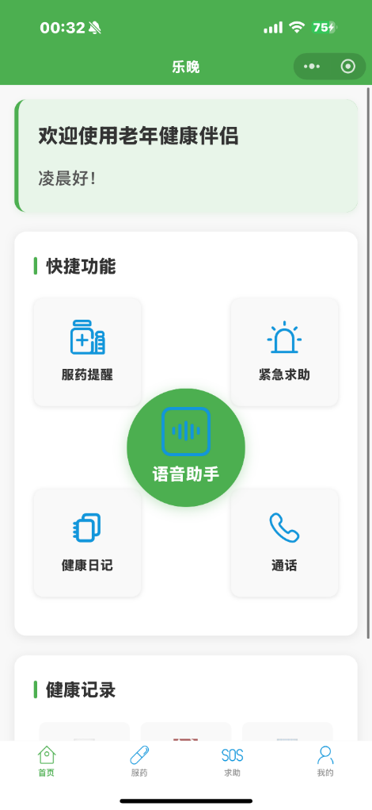
The mini program adopts a fixed four-tab bottom navigation design, so elderly users do not need to remember complex navigation paths.

Home (Comprehensive Entry) – Medication (Medication Management) – SOS (Emergency Assistance) – My Profile (Personal Settings)

4.1 Home(Health Hub)

a. Emotional Guidance
- Top welcome message: "Welcome to Elderly Health Companion!"
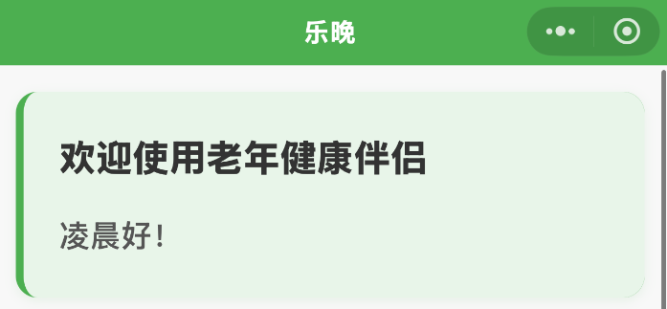

b. Five Quick Access Functions (Central Core Area)
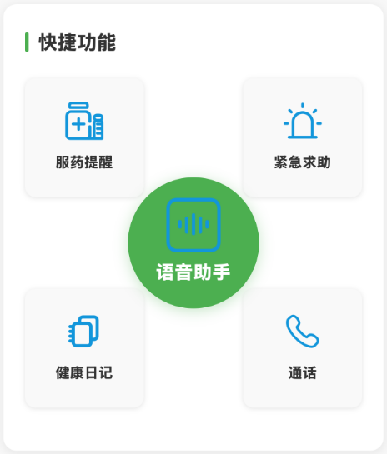

Icon | Function Name | Operation Description | Senior-Friendly Design Highlights
💊 | Medication Reminder | Tap to go directly to the "Medication" tab | High-contrast button: white text on red background
🆘 | Emergency Assistance | Tap to go directly to the "SOS" screen | Enlarged button size: 56×56px
📝 | Health Diary | Record blood pressure, etc. via voice/tap | Abnormal values automatically highlighted in red
📞 | Quick Call | Display a wall of 4 frequently used contacts | Avatar + name for double recognition, prevents mis-taps
🎤 | Voice Assistant | Centered floating button, press and hold to speak | Vibration feedback when pressed and held

c. Health Data Area (Bottom Visualization)
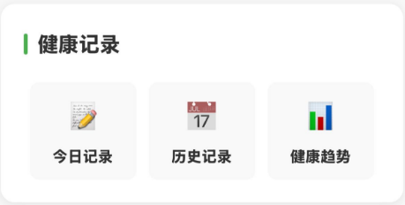
- Today's Records: Tap to enter and record today's health data and symptoms.
- History: Calendar view marks days with health anomalies (red dot indicator).
- Health Trends: Line charts for blood pressure/heart rate/blood sugar (supports pinch-to-zoom).

4.2 Medication Reminder Function (Medication Manager)
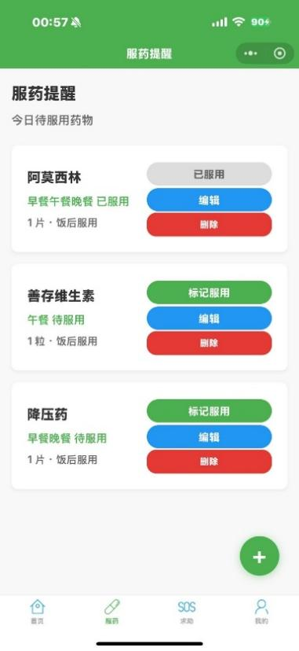

a. Dynamic To-Do List
- Medications to Take Today:
Displays the names of medications to be taken, dosage per intake, specific intake times, and whether the medication has been taken. Options are provided to edit or delete medications.
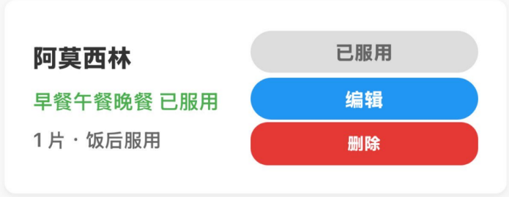

b. Medication Management Function
Tap the "+" button at the bottom right of the Medication page to add a new medication reminder.
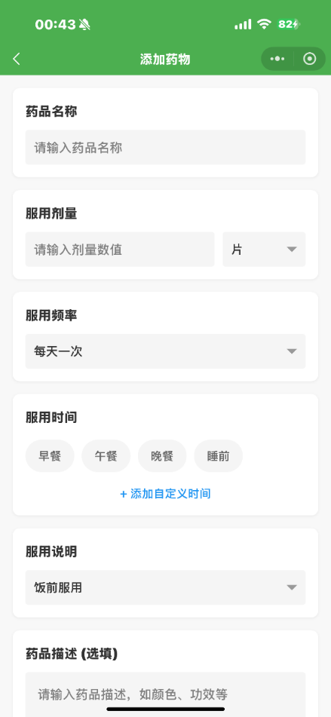
- Medication Name: Users can enter the specific name of the medication.
- Dosage: Users can input the exact dosage and select the unit: tablet/capsule/mg/ml/g/packet.
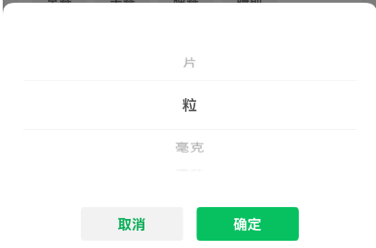

- Frequency: Users can select a specific intake frequency or customize it.
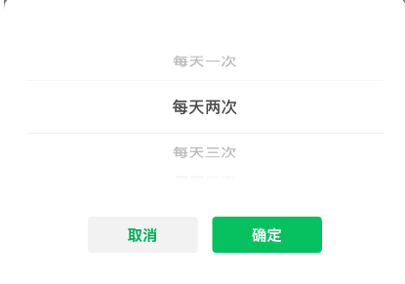
- Time of Intake: Options include breakfast/lunch/dinner/before bed, or a custom time.
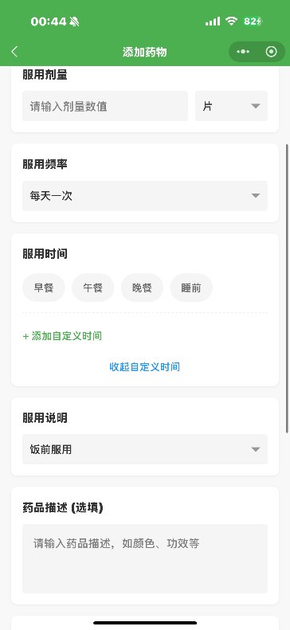
- Instructions: Users can specify intake instructions, such as before meals/after meals/with meals/on an empty stomach/before bed.
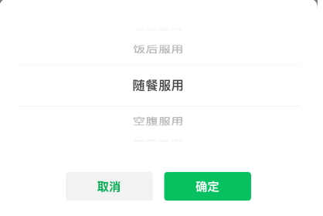
- Medication Description (Optional): Users can enter specific details about the medication, such as color, brand, efficacy, or precautions.
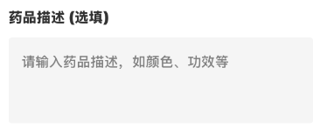
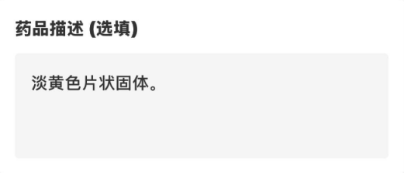
- Reminder Method: Users can choose the reminder method, including pop-up notification, voice broadcast, or both.
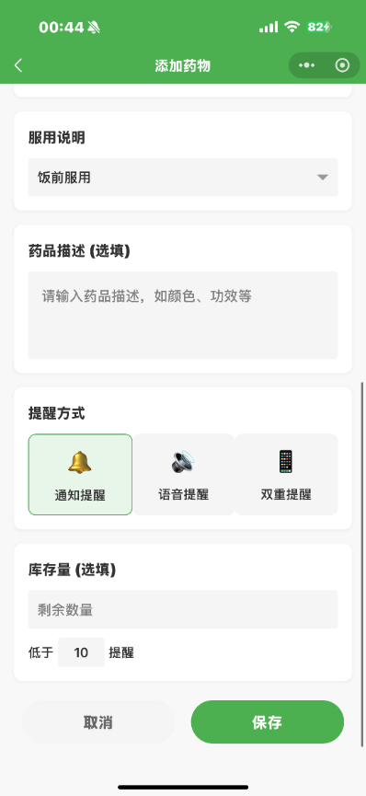
- Stock Quantity: Users can enter the remaining quantity of the medication, and the system will remind them to restock when it falls below a set amount.

4.3. SOS Emergency Assistance Function (Safety Shield)
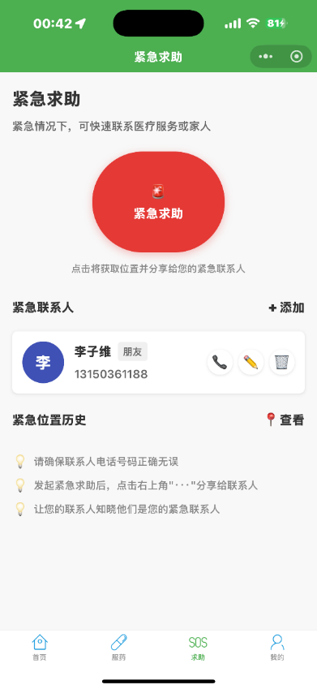

a. Emergency Response System
- Large Red Button: Occupies one-third of the screen area.
  - A pop-up confirmation appears before initiating an emergency request (to prevent accidental activation).
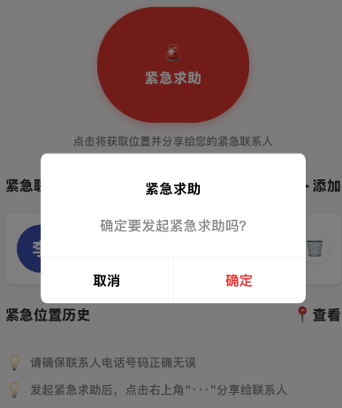
  - Once activated: Automatically sends the user's location to emergency contacts (via both WeChat and SMS), and dials 120 emergency services.

b. Emergency Contacts
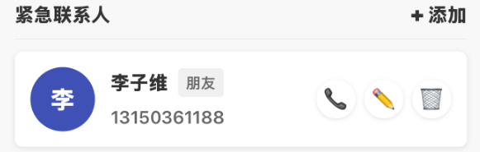
- Displays the nickname, relationship to the user, and phone number of each emergency contact.
- Options to call, edit, or delete a contact are provided.
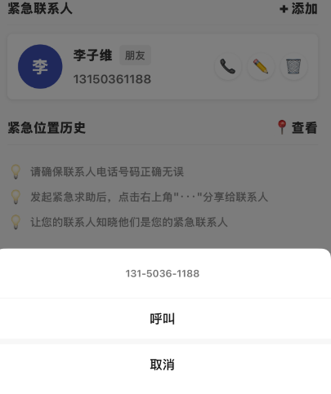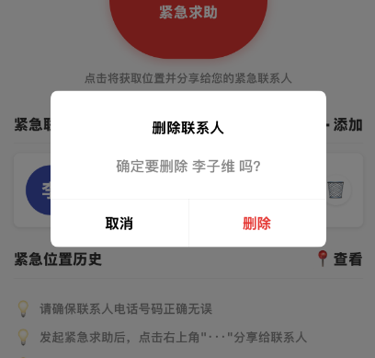
- Tap the plus icon on the right to add a new emergency contact, including name/nickname, relationship, and phone number. Relationship options include: Family, Doctor, Friend, Neighbor, Caregiver, or Other.

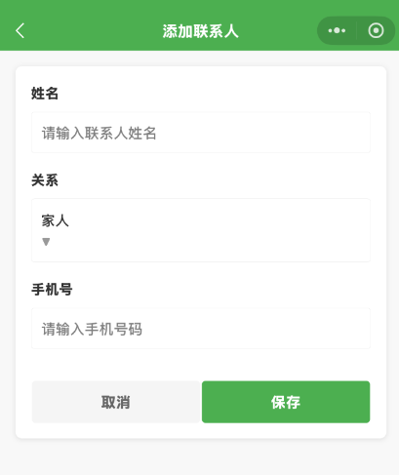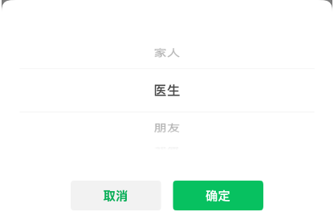

c. Historical Location Map
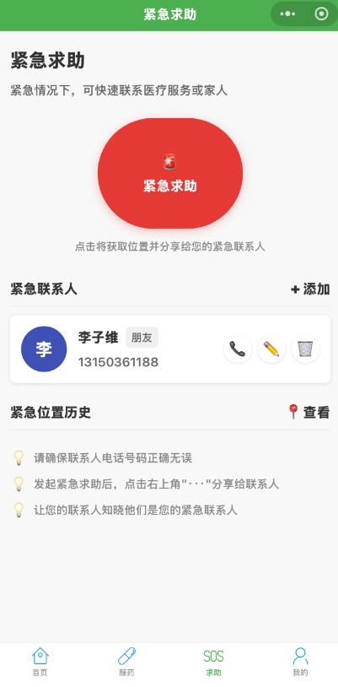
- Tap to view the history of shared emergency locations. Tap a specific record to view it on the map.
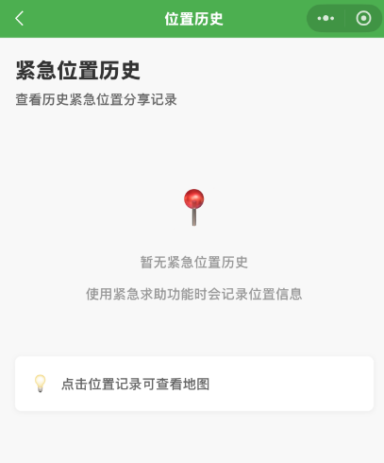

4.4 Health Management Function (Health Diary)
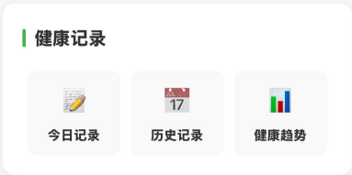
- Health Diary
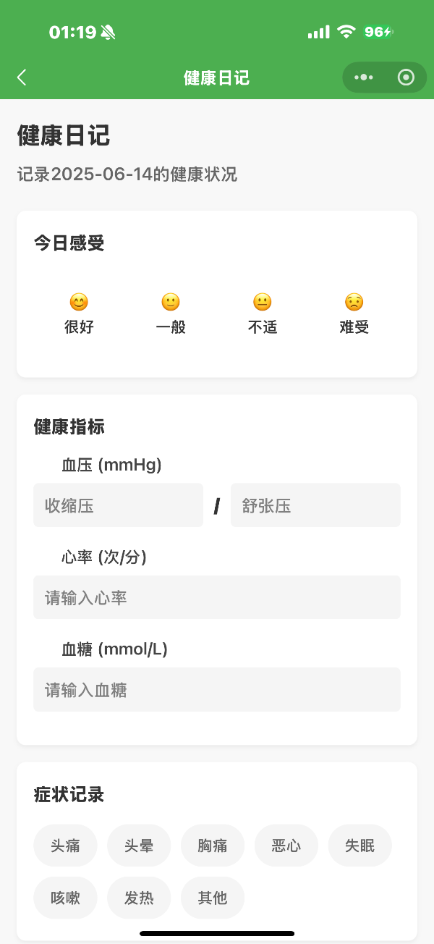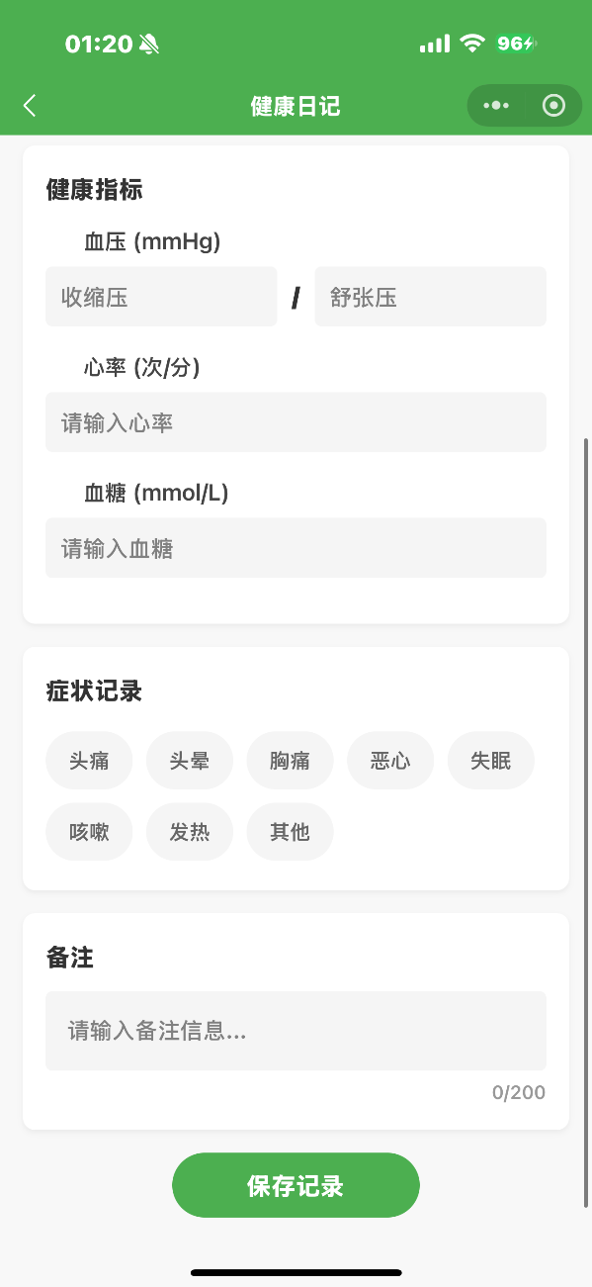
- Today's Feelings: Assess the user's psychological and mental state for the day, focusing on the mental health of the elderly.
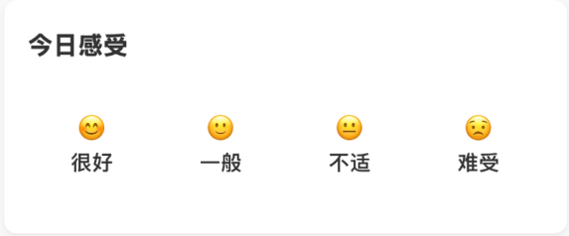
- Health Indicators: Evaluate basic health conditions, including blood pressure, heart rate, and blood sugar.
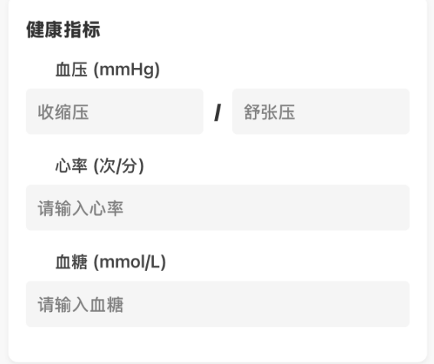
- Symptom Record: Seniors can record any physical discomfort here.
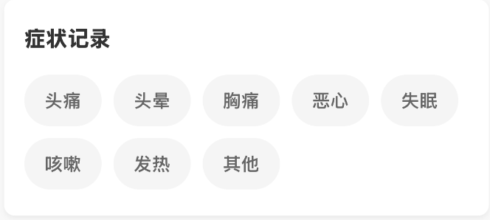
- Remarks: Users can add relevant notes, such as interesting events, schedules, or moods of the day.
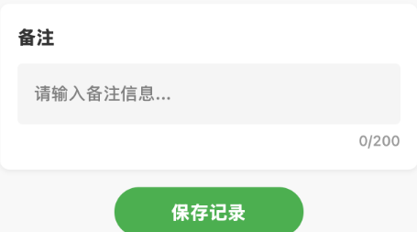

b. Historical Records
- Calendar List: Users can click on dates with existing health records to view the health status for that day; for dates without records, users can add health information retroactively.
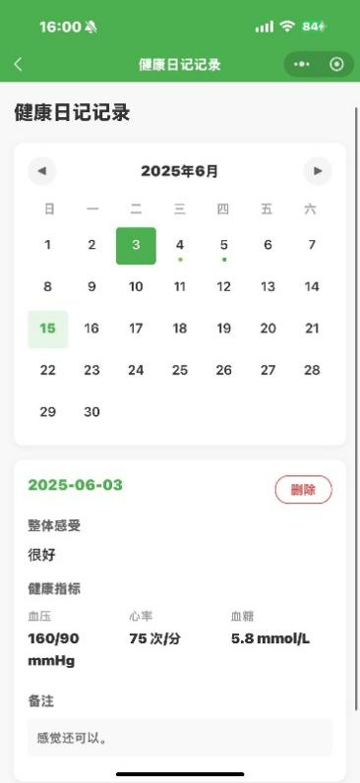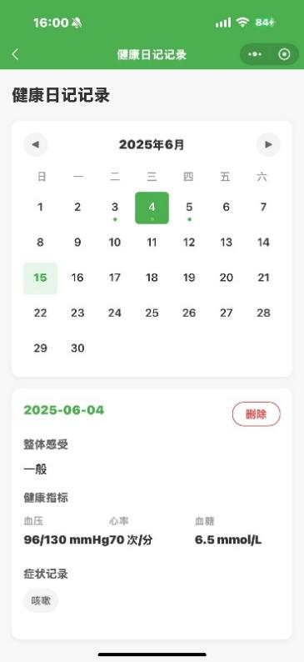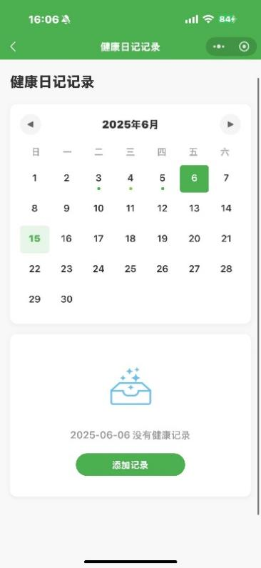

- Health Cards: Historical health cards display the overall feelings, basic health indicators, and user remarks for each day.

c. Health Trend Analysis
- Users can select which health data to analyze: blood pressure, heart rate, or blood sugar.
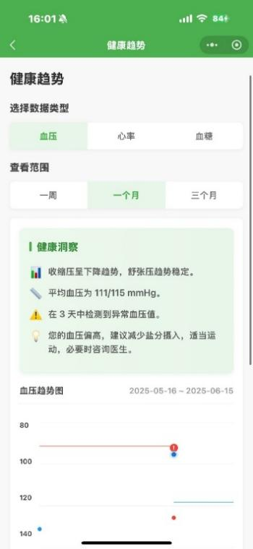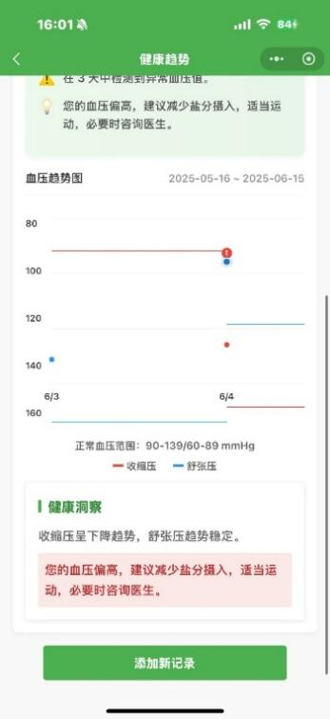
- Integration with large language models: Intelligently analyzes the data and provides health suggestions.
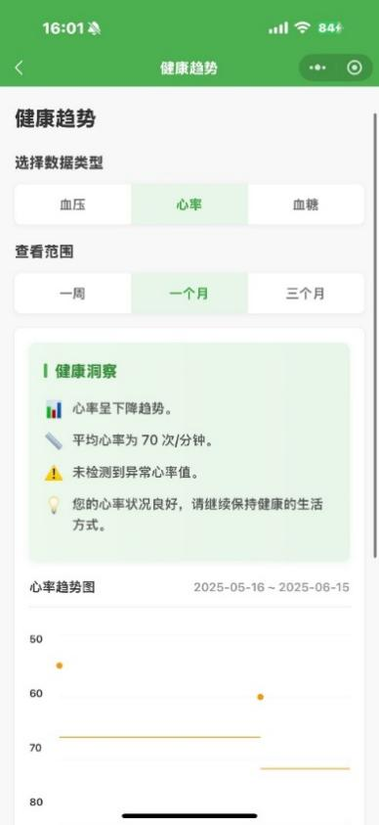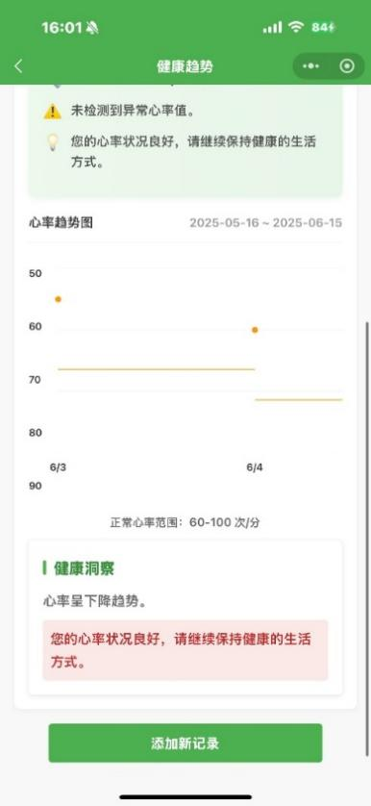
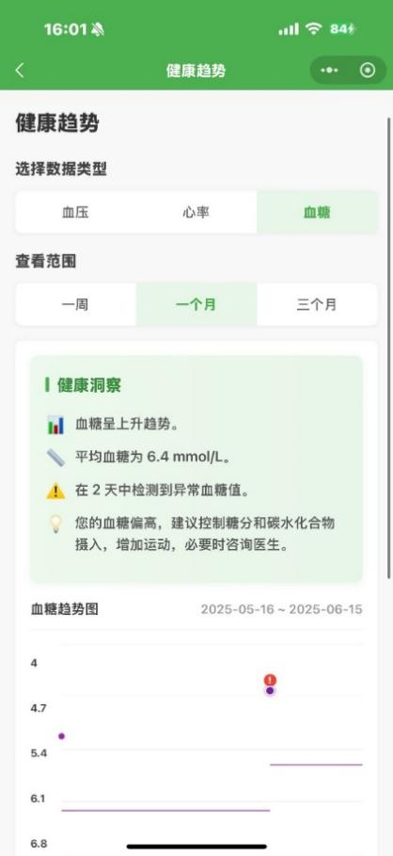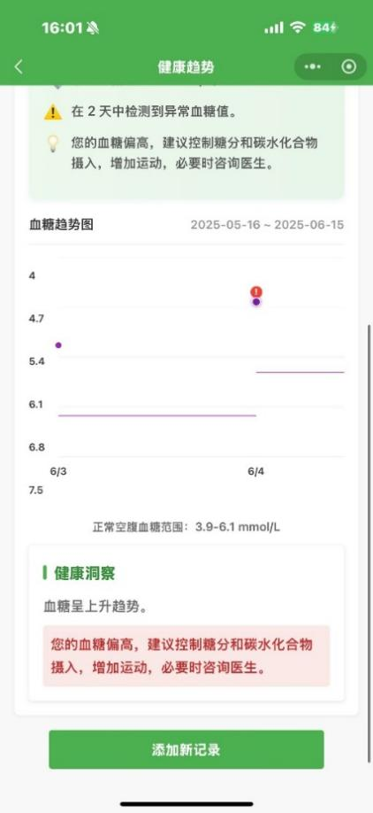

4.5 Calling Function
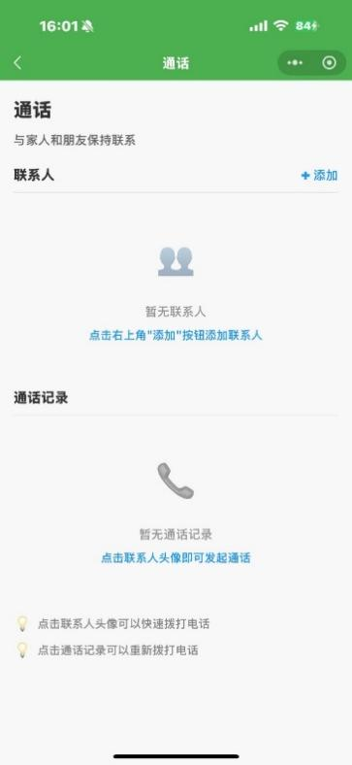
a. Add New Contact
- Emergency Contact Management: Relationship labels (Family/Doctor/Neighbor)
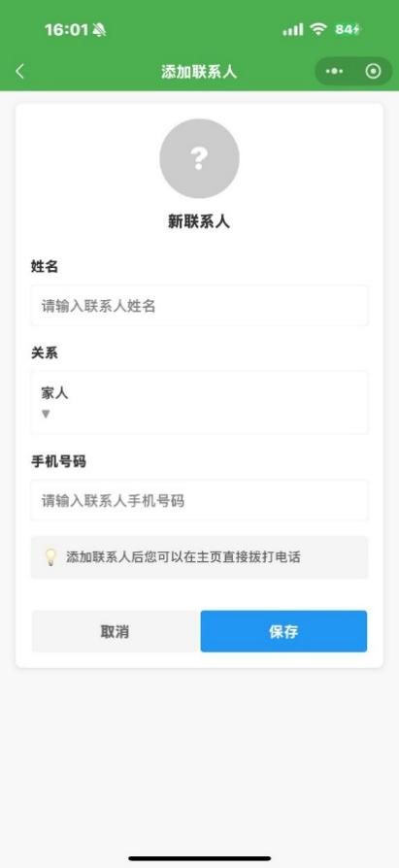
b. Dialing Page:Features large contact icons for easy use by elderly users.
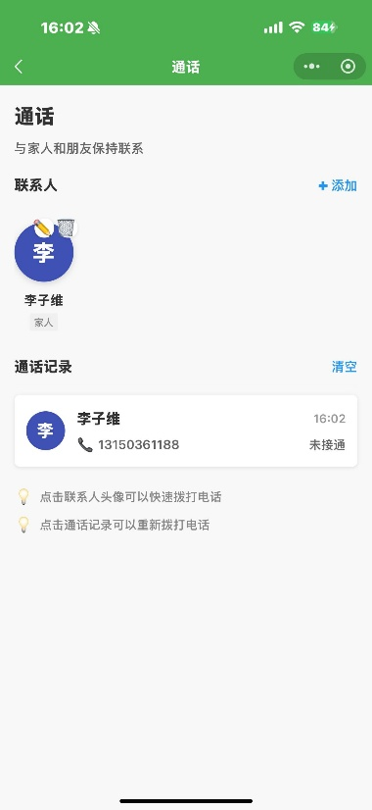
c. Call History:Tap to quickly redial previous calls.

4.6 Intelligent Voice Assistant Function
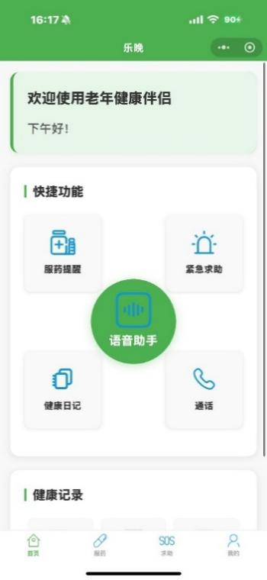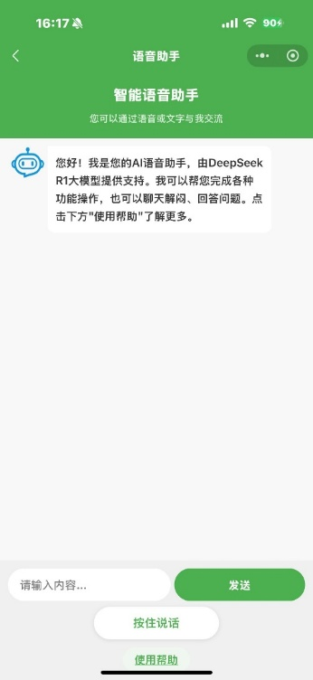
Tap the central "Voice Assistant" module on the home page to access the intelligent voice assistant powered by DeepSeek.
a. User Guide
- When entering the voice assistant for the first time, or by tapping the "Help" button at the bottom, a usage tutorial will pop up.
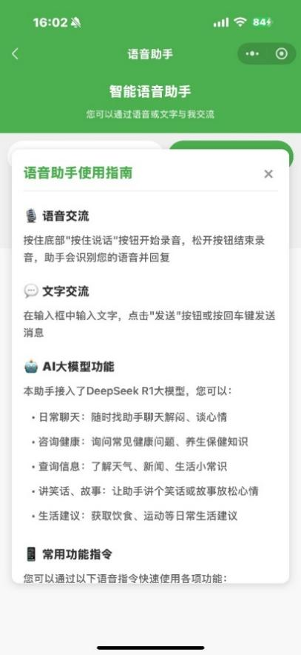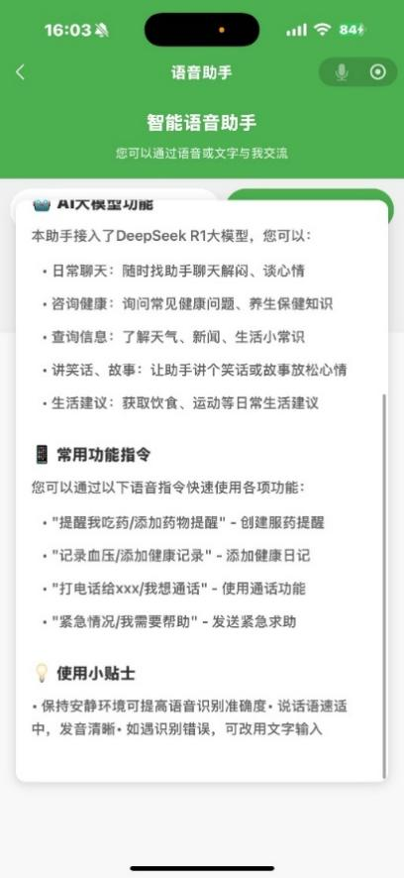
b. Voice Interaction：Press and hold the "Hold to Talk" button at the bottom to start recording; release to end recording. The assistant will recognize your speech and respond.
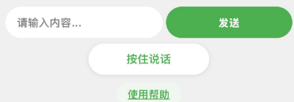
c. Text Interaction：Enter text in the input box and click the "Send" button or press Enter to send your message.
d. Common Commands:
•Daily Chat: Chat with the assistant anytime to relieve boredom or talk about your feelings.
•Health Consultation: Ask about common health issues or wellness tips
•Information Inquiry: Check the weather, news, or daily life tips
•Tell Jokes or Stories: Ask the assistant to tell a joke or story to lighten the mood
•Life Advice: Get suggestions on diet, exercise, and other daily routines

You can quickly use various functions with the following voice commands:
•"Remind me to take medicine / Add a medication reminder" — Create a medication reminder
•"Record blood pressure / Add a health record" — Add a health diary entry
•"Call xxx / I want to make a call" — Use the calling function
•"Emergency / I need help" — Send an emergency assistance request
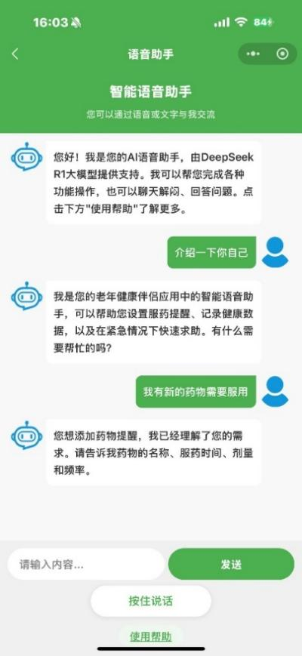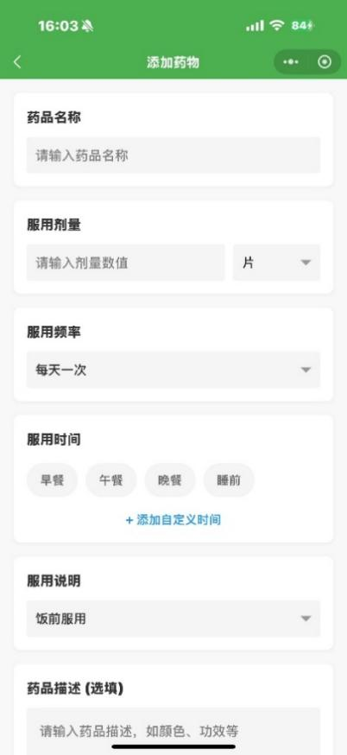
e. Example:As above, if you tell the voice assistant you want to add a new medication reminder, it will automatically navigate to the medication addition module, making it easier for elderly users to operate.

4.7 Personal Center Page
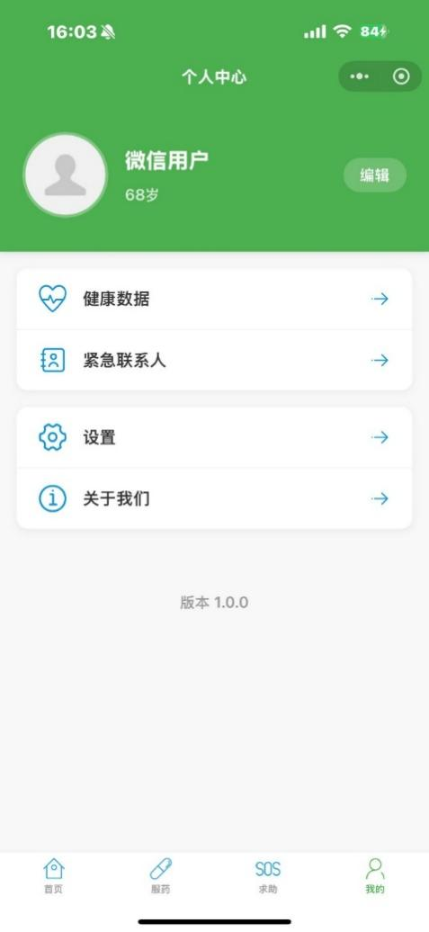

a. Access to features such as "Health Data" and "Emergency Contacts" from this page.

b. Edit user profile information: modify name, age, or profile picture.
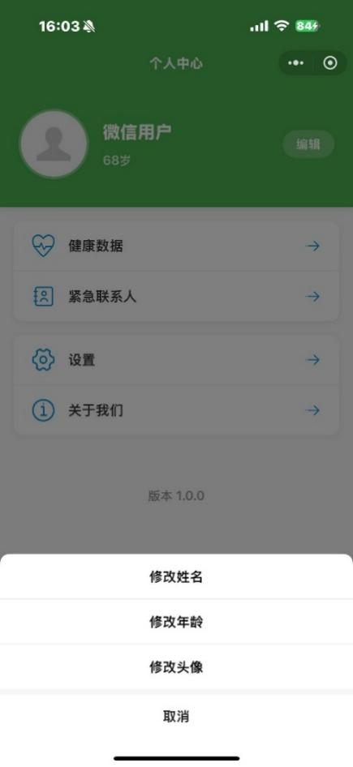

c. Settings page
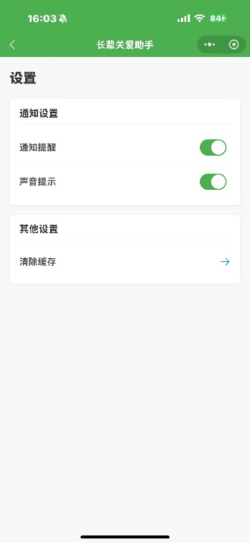

d. Developer introduction page
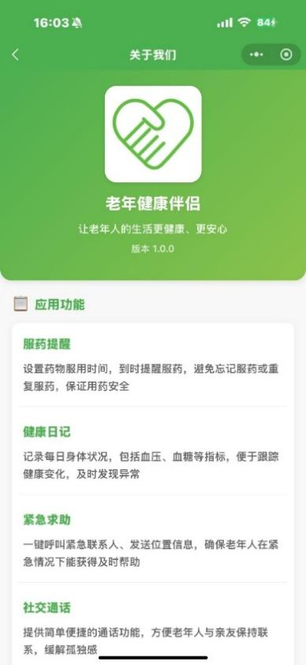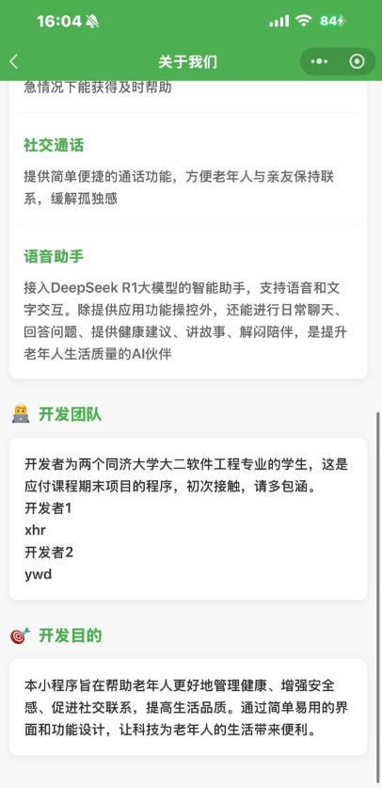

- Advantages and Limitations of the Program
  - Advantages
    - Strategic Advantages of Platform Selection
Choosing WeChat Mini Program as the development platform for the "Elderly Health Companion" brings significant strategic benefits. Firstly, WeChat has a high penetration rate among the elderly population in China, providing a vast potential user base for the application. Secondly, developing on the WeChat platform eliminates the need for independent app installation, greatly lowering the usage threshold for elderly users. Thirdly, the lightweight nature of WeChat Mini Programs allows for fast startup and low resource consumption, making it suitable for the mid- to low-end devices commonly used by seniors. Fourthly, WeChat's ecosystem offers essential services such as identity authentication, payment, and maps, which facilitate the implementation of application features and avoid redundant development of these basic modules.

    - Targeted Functional Design
The program's functional design is highly tailored to the specific needs of elderly users. The health management module not only focuses on basic medication reminders but also extends to health record-keeping and trend analysis, creating a complete health monitoring loop. The safety assurance module, considering the high incidence of emergencies among seniors, provides one-click emergency assistance and location sharing. The social module simplifies address book operations, directly meeting the core social needs of the elderly in a convenient way. The intelligent assistant module leverages voice interaction technology to effectively solve the difficulties seniors face with complex interfaces, while also enhancing their sense of participation and confidence in using modern smart tools.
This multidimensional integration of functions significantly enhances the practical value of the application, forming a one-stop life assistant solution for seniors.

    - User-Friendly Interface
In terms of interface design, the program fully considers the visual perception characteristics and operational habits of elderly users. Firstly, the app adopts a high-contrast visual design to ensure information is clear and easy to read. Secondly, interface elements are arranged in a simple and orderly manner, with each page displaying only essential information to reduce cognitive load. Thirdly, interactive elements such as buttons are designed in large sizes with clear visual feedback, making them easy to operate for users with reduced fine motor skills. Fourthly, the app provides clear operational guidance and help prompts for key functions, lowering the learning curve.
The comprehensive use of these design elements gives the program a distinct advantage in usability, making it especially suitable for elderly users with relatively low digital literacy.

    - Technological Innovation and Integration
The program successfully integrates several popular intelligent technologies to provide innovative interactive experiences for elderly users. The application of speech recognition technology addresses the difficulty seniors face in text input, and the integration of Tencent Cloud's SentenceASR service offers high accuracy in Chinese speech recognition. The incorporation of the DeepSeek R1 large language model endows the app with the ability to understand natural language and execute complex commands, allowing seniors to complete operations through simple conversations.
This fusion of voice and AI technologies creates a more natural and intuitive human-computer interaction, effectively lowering the technical barrier for seniors to use smart applications, while also providing them with opportunities to experience cutting-edge technology and narrowing the digital divide.

    - Seamless Integration with the WeChat Ecosystem
The program makes full use of the technical capabilities provided by the WeChat ecosystem to achieve seamless integration of multiple functions. By utilizing WeChat's location services, the app can accurately obtain user location information for emergency assistance. Leveraging WeChat's address book and calling features simplifies social contact operations. The WeChat Cloud Development platform streamlines backend service construction and maintenance. This deep integration with the WeChat ecosystem not only improves development efficiency but also ensures functional stability and a consistent user experience.
  - Limitations
    - Constraints of Platform Dependency
Although choosing the WeChat Mini Program platform brings many advantages, it also results in obvious platform dependency.
Firstly, users must have a WeChat account and be familiar with basic WeChat operations to use this application, which poses a barrier for the small minority of seniors who do not use WeChat. Secondly, the app's functions are limited by the capabilities of WeChat Mini Programs, such as background running time restrictions that affect the implementation of long-term monitoring features. Thirdly, WeChat's review mechanism for mini program content and functions may also limit the launch of certain features. This dependency to some extent restricts the app's autonomy and potential for functional expansion.

    - Technical Challenges and Shortcomings
On the technical level, the program faces several implementation challenges.
Although the speech recognition feature is innovative, its accuracy drops significantly in noisy environments or when dealing with speech characteristics common among seniors (such as unclear articulation or strong dialects). While the AI model's comprehension is advanced, it still struggles to fully understand complex commands or highly context-dependent requests. There may be delays in cloud function calls, affecting real-time user experience. The mini program's ability to process complex health data is limited, making it difficult to provide professional-level health analysis. These technical limitations affect the app's effectiveness in certain scenarios.

    - The Digital Divide Among User Groups
Although the program strives to provide convenient digital services for seniors, it is still difficult to completely eliminate the digital divide.
There are significant differences in digital literacy among elderly users. For those with very little experience using digital devices, even a simplified interface may present cognitive barriers. Some features (such as health data trend analysis) require a certain level of user understanding, which may exceed the cognitive range of some seniors. This digital divide limits the app's popularity among users with low digital literacy.

    - The Dilemma Between Professionalism and Usability
During the functional design process, the program constantly faces trade-offs between professionalism and usability. For example, the health management function sacrifices some medical professionalism for simplified operation and cannot provide prescription-level medication management. The safety assurance function, for the sake of ease of use, does not integrate more complex emergency guidance or telemedicine services. The intelligent assistant limits its freedom to ensure accurate understanding, making it difficult to support complex conversational scenarios.
This dilemma between professional depth and ease of use means that the app cannot meet the advanced needs of professional users in certain areas, limiting its potential service value.

- Future Directions for Improvement
  - Optimization and Upgrade of Intelligent Voice Interaction
The current voice assistant function already supports basic speech recognition and intent understanding, but still faces issues such as low recognition accuracy and limited contextual comprehension.
Future improvements can focus on the following aspects:
First, develop dedicated speech recognition models tailored to elderly users' speech characteristics (such as unclear pronunciation, slower speech, and strong dialect features) to improve recognition accuracy;
Second, enhance dialogue management capabilities to enable multi-turn conversations and contextual memory, making interactions more natural and smooth;
Third, expand the knowledge graph so the assistant can answer a wider range of health and daily life questions, becoming a true knowledge companion for seniors;
Fourth, develop emotion recognition capabilities to assess users' emotional states based on tone and word choice, providing more empathetic responses.
These improvements will greatly enhance the practicality and friendliness of the voice assistant, making it a true intelligent companion for the elderly.
  - Intelligent Analysis and Early Warning of Health Data
Currently, the health management function mainly focuses on recording, simple algorithm estimation, and chart display, lacking in-depth analysis and early warning capabilities.
Future versions plan to introduce more advanced health data analysis algorithms to achieve the following:
Health trend prediction, analyzing changes in physical indicators based on historical data to warn of potential health risks;
Medication adherence analysis, evaluating medication regularity based on user records and providing suggestions for improvement;
Health report generation, regularly summarizing user health data into concise reports for easy sharing with doctors.
These features will upgrade the app from a simple recording tool to an intelligent health management assistant, providing users with more valuable health guidance.

  - Construction of a Remote Care System
Considering that many elderly people live apart from their children, future versions will focus on building a remote care system to strengthen family connections and support.
Specific features include:
Authorizing family members to remotely view seniors' health data and monitor their health status;
Setting up automatic alerts for abnormal situations, such as notifying family members when abnormal health data is detected or when the user is inactive for a long time;
Developing a "one-click emergency" video call function, allowing seniors to quickly connect with family members via video in times of need;
Adding lifestyle monitoring features, such as reminders to drink water or exercise, with family members able to set and adjust reminders.
These features will form a virtual "family care network," ensuring the safety and health of seniors while reducing the psychological burden on their children.

  - Integration of a Community Mutual Aid Platform
In addition to family care, community support is also crucial for the quality of life of the elderly.
Future versions plan to build a location-based community mutual aid platform, including:
Aggregating and pushing information about nearby senior activities to encourage participation in community events;
Matching interest groups among elderly users to promote social connections among those with similar interests;
Connecting seniors in need with community volunteers;
Supporting skill sharing and mutual aid among seniors, enabling value creation and support within the elderly community.
This platform will help seniors overcome physical space limitations, expand their social circles, and enhance their sense of community belonging, thereby improving overall life satisfaction.

  - Personalized User Adaptation
Future versions will introduce a more robust personalized adaptation system that automatically adjusts the interface and functions based on users' habits, cognitive abilities, and preferences:
Dynamically adjust interface element size, layout, and operation flow based on user behavior analysis;
Intelligently adjust home page content according to frequently used features;
Provide personalized function guidance based on usage frequency and difficulty;
Support multiple font sizes, color schemes, and operation modes.
This highly personalized design will enable the app to better accommodate differences within the elderly population, providing each user with the most suitable experience for their abilities and needs.
Through these improvements, the "Elderly Health Companion" will achieve comprehensive upgrades in functionality, technical maturity, user adaptability, and service continuity, truly becoming a reliable digital life companion for seniors and offering innovative technical solutions to the challenges of elderly care in an aging society.

- Conclusion
The "Elderly Health Companion" is a WeChat mini program specifically designed for elderly users, aiming to improve their quality of life and health through digital means. The project originated from the observation of a gap in the domestic market for medication reminder apps for seniors, combined with an in-depth analysis of the aging society and the digital behavior characteristics of elderly users. Ultimately, it evolved into a comprehensive service platform integrating health management, safety assurance, social communication, and intelligent assistance.
The app's functional design is highly aligned with the needs of elderly users:
Medication reminders and health record features help seniors regulate medication behavior and monitor health status;
The emergency assistance system enhances their sense of security;
Simplified social tools maintain connections with family and friends;
Voice interaction technology lowers the threshold for seniors to use smart applications.
In terms of user interaction, the app adopts a high-contrast interface and simplified operation flow, fully considering the visual and operational characteristics of elderly users.
On the technical side, the project successfully integrates WeChat mini programs, Tencent Cloud speech recognition, and the DeepSeek large language model, bringing together multiple functions on a lightweight platform to create an intelligent and convenient digital experience for seniors. Although challenges remain in platform dependency, technical implementation, and commercial sustainability, continuous optimization and feature expansion are expected to make the app an effective technical solution for addressing the challenges of an aging population.
The "Elderly Health Companion" is not only a practical tool, but also represents a positive exploration of technology for aging populations. It provides a feasible path for narrowing the digital divide and promoting the integration of seniors into the intelligent society, embodying the innovative value and social significance of technology-empowered elderly care.

